SECTION LC

AIR INLET AND EXHAUST MANIFOLDS

CONTENTS

|  |  |
| --- | --- |
|  | Chapter |
| Air Shutdown Valve and Bends | 1 |
| Air Inlet Manifolds .. | 2 |
| Charge Air Heater/Cooler .. | 3 |
| Turbocharger .. | 4 |
| Exhaust Manifolds .. | 5 |
| Inspection | 6 |
| Special Tools.. | 7 |

AIR SHUTDOWN VALVE

Removal (Fig LC.l)

1. Slacken and remove clamp band (13). Remove setscrews (15) separate and lift away air bend (14). Withdraw end piece (11). Remove setbolts (55) and adaptor (56).
2. Remove setscrews (2) and (61), separate and lift away delivery bend (1). Blank off the turbocharger aperture.
3. Disconnect oil pipe (8).
4. Release setscrews (5) and remove microswitch (4) complete with bracket (6) and tufnol packing (7).
5. Support the weight of air shutdown valve (59), remove setscrews (10) and lift the valve away.
6. For servicing instructions regarding the shutdown valve refer to Section HD.

Fitting (Fig LC.l)

NOTE 1 Domed washers are fitted beneath the heads of all setscrews and setbolts unless otherwise stated and are of the schnorr disc spring type. They must be fitted with the dome towards the head of the setscrew.

2 All joints and 'O' rings must be fitted dry.

1. Place new 'O' ring (58) into its groove in adaptor (56). Using a new joint (57) fit adaptor to air shutdown valve (59) and secure with setbolts (55) and domed washers. Apply 'Rocol Dryfilm' anti-scuffing spray to the bore of the adaptor and to end piece (11) and insert the end piece into the adaptor.
2. Offer-up air shutdown valve (59) to bracket (9) and fit setscrews (10) and domed washers. DO NOT fully tighten.
3. Using new joints (3) and (60), fit delivery bend (1) and secure with setscrews (2) and (61) and domed washers. DO NOT fully tighten.
4. Apply sufficient petroleum jelly to new 'O' ring (12) to prevent it falling out and place the 'O' ring in the groove in end piece (11).
5. Using a new joint (54), fit air bend (14) and secure with setscrews (15) and domed washers. DO NOT fully tighten.
6. Slide end piece (11) into contact with air bend (14). Adjust the position of all components, whilst tightening the fastenings, to maintain the best possible alignment. Fit and tighten clamp band (13).
7. Fully tighten setscrews (2), (10), (15) and (61).
8. Connect oil pipe (8).
9. Fit microswitch (4) complete with bracket (6) and tufnol packing (7). Secure with setscrews (5) and spring washers. Check remote operation of microswitch with air shutdown valve in closed position.

LIMITED RIGHTS LEGEND

USE, DUPLICATION OR DISCLOSURE OF THIS INFORMATION WHICH IS THE PROPERTY O

OF GEC ALSTHOM DIESELS LIMITED BY THE U.S. GOVERNMENT OR BOLLINGER IS **3**

SUBJECT TO THE RESTRICTIONS SET FORTH IN DOD FAR SUPP 252.227-7013 (a) 15.

AIR INLET MANIFOLDS

Removal (Fig LC.l)

1. Isolate the fuel supply and drain the fuel system (Section GB).
2. Remove the cover over the fuel injection pump linkage.
3. Remove the fuel injection pipes (Section GJ).
4. Remove the fuel return pipes between the injection pumps and the upper fuel rail mounted on the air inlet manifold. Remove the upper fuel rail and sufficient of the fuel supply piping to gain access to the air inlet manifold setbolts.
5. Remove air pipe (46)(Fig LC.l) to fuel limiter ('A' bank only).
6. Remove air pipe (42) to water washing equipment.
7. Remove the 'Start Pilot' piping from the air inlet manifold (Section NB).
8. Slacken locknuts (69). Hold locknut whilst removing setscrew (67). Remove oil

ferrule (65) and withdraw drain adaptor (63) from drain pipe (62).

1. Remove condensate drain valve (38) to prevent damage.
2. Remove setbolts (35), setscrews (36) and setscrew (34).
3. Remove setscrews (31), setbolts (29) and distance pieces (30), and lift away the air inlet manifold. Remove tee piece (44)(’A' bank only).
4. Remove air delivery pipe (33) by easing it out of adaptor (52). Remove setbolts (32) and remove adaptor (52).
5. Repeat the above for the opposite bank air inlet manifold.
6. For inspection procedures refer to Chapter 6 of this Section.

Fitting (Fig LC.l)

NOTES 1 With the exception of joint (53) all joints in the air intake system are graphited and should befitted without jointing compound.

2 Domed washers are fitted beneath the heads of all setscrews and setbolts unless otherwise stated and are of the schnorr disc spring type. They must be fitted with the dome towards the head of the setscrew.

1. Use new joints and 'O' rings throughout.
2. All joints and 'O' rings must be fitted dry.
3. Fit new 'O' ring (26) to its groove in adaptor (52). Apply 'Rocol Dryfilm' anti­scuffing spray to the bore of the adaptor and to the contact surface of air delivery pipe (33). Position joint (53) on adaptor (52).
4. Place the air delivery pipe in position. Insert setscrew (34), together with domed washer, into its hole in the pipe flange. DO THIS BEFORE assembling drain adaptor (63) as there is insufficient room to insert the setscrew afterwards.
5. Using a new 'O' ring, insert drain adaptor (63) into drain pipe (62). Place ferrule

(65) in position, assemble setscrew (67) to the drain adaptor as shown, and screw it into the air delivery pipe. Do not attempt to position the drain adaptor at this stage. It should also be noted that one setbolt on 'B' bank manifold, marked 'X' (Fig LC.l) fouls a mounting facing on the oil cooler and must be entered through the manifold before putting the manifold in place.

1. Using new joints (50) and (51), offer up air manifold (49) and secure to the cylinder

heads with setscrews (31) and domed washers, and setbolts (29), distance pieces

(30) and domed washers.

1. Secure the manifold to the air delivery pipe with setscrews (34) and (36), and setbolts (35). Fit domed washers to all setscrews. Adjust the position of drain adaptor (63) by means of setscrew (67) and locknuts (69) to tension ferrule (65) and gain optimum contact on 'O’ rings (64) and (66).
2. Fit fuel limiter air pipe (46)('A' bank manifold only).
3. Using a new dowty washer (45) fit tee piece (44)('A' bank only).
4. Using a new dowty washer (43) fit condensate drain valve (38) to the air manifold. Fit plastic drain tubing (37).
5. Repeat the above for opposite bank of engine.
6. Fit the upper fuel gallery to the air manifold. Tighten the pipes between the fuel injection pumps and the upper gallery before tightening the gallery to the manifold. Connect the fuel supply piping.
7. Fit the 'Start Pilot' piping to the air inlet manifolds (Section NB).
8. Fit the fuel injection pipes (Section GJ).
9. Fit the covers to the longitudinal fuel injection pump control linkage.

CHARGE AIR HEATER/COOLER

Removal (Fig LC.l)

1. Isolate and drain the coolant system and sea water system (Section KA).
2. Isolate and drain the fuel system (Section GB).
3. Disconnect and remove sea water piping between the sea water pump and charge air heater/cooler and the charge air heater/cooler and lubricating oil cooler. Remove engine coolant piping from charge air heater/cooler.
4. Remove clamp band (13), setscrews (15) and air bend (14).
5. Disconnect the fuel supply and return piping at the fuel oil reservoir. Remove

securing setscrews and remove the reservoir from the charge air heater/cooler.

1. Remove setbolts (32) and ease adaptors (52) away from delivery casings (25).
2. Remove setbolts (23)(Fig LC.2) securing the charge air heater/cooler to support bracket (21). Fit 2 eyebolts to the M16 tapped holes in the charge air heater/cooler top cover and lift the charge air heater/cooler away. The weight of charge air heater/cooler approximately 196 kg.
3. Remove setbolts (17)(Fig LC.l), (18) and setscrews (19). Remove inlet casing

(20).

1. Remove setscrews (24) and remove delivery casing (25).
2. For servicing instructions regarding the charge air heater/cooler refer to Section KD.

Fitting (Fig LC.l)

NOTE NOTE All joints and 'O' rings must befitted dry.

1. Using a new joint (21), fit inlet casing (20) to the charge air heater/cooler. Secure with setscrews (19) and domed washers, 2 off setbolts (18) and domed washers, one at the top and bottom of the casing and five off setbolts (17) and dowty washers (16).

NOTE Setbolts (17) pass through the air spaces and the dowty washers are necessary to seal the bolt heads.

1. Using a new joint (23) fit delivery casing (25). Secure with setscrews (24) and domed washers.
2. Screw two M16 eyebolts into the top casing of charge air heater/cooler (22) and lift the cooler into position onto bracket (21)(Fig LC.2). Fit securing setbolts (23) and domed washers, DO NOT fully tighten.
3. Fit domed washers and setbolts (32)(Fig LC.l) and tighten securely. Tighten charge air heater/cooler securing setbolts.
4. Locate new 'O' ring (12) in end piece (11). Using a new joint (54), offer up air bend
5. and secure with setscrews (15) and domed washers. Slide end piece (11) into contact with air bend (14) and fit and tighten clamp band (13).
6. Fit the sea water pipes between charge air heater/cooler and sea water pump and between charge air heater/cooler and lubricating oil cooler.
7. Secure fuel oil reservoir to delivery casing and connect the fuel piping.
8. Turn on the fuel supply. Prime and vent the system in accordance with Section DA.

CHAPTER 4

TURBOCHARGERS

Removal (Fig LC.2)

1. Isolate and drain the cooling system (Section KA).
2. Remove engine governor.
3. Remove main exhaust pipe from turbocharger, if engine is installed.
4. Remove coolant vent piping from top of turbocharger.
5. Remove air shutdown valve and bends (Chapter 1).
6. Remove air intake filters and intake casing (Section LA).
7. Remove coolant pipe between turbocharger and remote heating unit.
8. Remove coolant pipes (5) between turbocharger (1) and and turbine inlet casing (9).
9. Remove setscrews (38) and (40), distance pieces (44) and (45) and bracket (39). Remove philidas nuts (48) and bracket (46). Bend back locking plates (42), remove setbolts (41) and support bracket (43).
10. Remove the oil supply piping, restrictor and brackets.
11. Remove clamp (62), setscrews (56) and philidas nuts (64). Slacken flexible couplings (60) and (61),remove drain pipe (63), drain bend (57) and elbow (59).
12. Remove setbolts (31) and (34) and coolant bend (32).
13. Release couplings (27), release setscrews (28) and remove coolant 'Y' piece (30).
14. Remove the coolant pipe between connecting pipe (19) and outlet elbow (6). Remove setscrews (20) setbolts (16) and remove connecting pipe (19), and sleeve (17).

NOTE It will not be possible to remove philidas nuts (49) without lifting the turbocharger slightly.

1. Remove setbolts (24) and (35), and philidas nuts (49).

NOTE The turbocharger assembly consists of 3 main components;

turbocharger (1), turbine inlet casing (9) and exhaust bend (14). The assembly can be lifted from the engine complete and in one piece providing lifting gear capable of supporting the weight of the assembly 750 kg (1650 lb) approximately) is available. If lifting is difficult or if space is restricted it is permissible to separate the main components prior to removal. Strip down procedure is similar regardless of whether the assembly is in situ on the engine or the workbench.

1. Remove philidas nuts (12), and ease exhaust bend (14) away from turbine inlet casing (9) and lift clear. Seal up all apertures.
2. Remove philidas nuts (37) on the outside of turbine inlet casing (9) and centre nut (13) and ease turbine inlet casing (9) from its dowel location with the turbocharger and lift away.
3. Lift away turbocharger.

LIMITED RIGHTS LEGEND

8

USE, DUPLICATION OR DISCLOSURE OF THIS INFORMATION WHICH IS THE PROPERTY

OF GEC ALSTHOM DIESELS LIMITED BY THE U.S. GOVERNMENT OR BOLLINGER IS SUBJECT TO THE RESTRICTIONS SET FORTH IN DOD FAR SUPP 252.227-7013 (a) 15.

1. Remove capscrews (51) and separate turbocharger foot (50) from the turbocharger. Remove 'O' rings (52) and (53).
2. The turbocharger may now be maintained in accordance with Section M. For Inspection procedures regarding the turbine inlet casing and exhaust bend refer to Chapter 6 of this Section.

Fitting

NOTES 1 Domed washers are fitted beneath the heads of all setscrews and setbolts unless otherwise stated and are of the schnorr disc spring type. They must be fitted with the dome towards the head of the setscrew.

1. Use new 'O' rings and joints throughout.
2. All joints and ’O' rings must be fitted dry.
3. Fit oil drain adaptor (54) to turbocharger (1). Tighten firmly using claw spanner (Chapter 7).
4. Fit 'O' ring (53) to the drain adaptor and fit 'O' ring (52) to turbocharger foot (50). Place the foot in position locating it with drain adaptor (54). Fit capscrews (51) and tighten to a torque loading of 168 Nm (124 lbf/ft).

NOTE The turbocharger assembly consists of 3 main components;

turbocharger (1), turbine inlet casing (9) and exhaust bend (14). The assembly can be lifted and placed on the engine complete and in one piece providing lifting gear capable of supporting the weight 750 kg (1650 lb) approximately is available. If lifting is difficult, or if space is restricted, it is permissible to build up the assembly on the engine, provided that, initially, 'O’ rings (15) and (16)(Fig LC.3) are left out to prevent damage to them when the components are brought together. If this course of action is chosen it will still be necessary to lift the complete assembly in order to put the 'O' rings etc., into their grooves, and so it will be seen that there is some advantage to be gained by building up off engine if possible. Alternatively, the 'O’ rings can be well greased and great care taken when sliding the components together. Build procedure is similar either on or off- engine.

1. Check that dowel (8)(Fig LC.2) is in position in turbine inlet casing (9).
2. Place joint (7) in position and bring the turbocharger and inlet casing together. Fit plain washers and philidas nuts (13) and (37), nip up, but DO NOT FULLY TIGHTEN at this stage.
3. Place 'O' rings (10) and (11) in position and locate the exhaust bend (14) to the inlet casing. Fit plain washers and philidas nuts (12), nip up, but DO NOT FULLY TIGHTEN at this stage.

NOTE 'O’ rings (15)(Fig LC.3) fitted to the coolant aperture between the exhaust ports are manufactured from a special heat resistant material.

1. Place 'O' ring (34), 'O’ rings (15)(Fig LC.3), and (16) in position in their grooves in the exhaust manifolds.

NOTE Philidas nuts (49)(Fig LC.2) should be started as soon as sufficient thread appears through turbocharger foot (50). Once the turbocharger is completely lowered it will be impossible to fit the two rear nuts.

1. Attach suitable lifting gear to lifting bracket (2)(Fig LC.2), and also to the exhaust bend end. Lift and lower the assembly on to the exhaust manifolds. Fit philidas nuts (49)(NO WASHERS), and setbolts (24) and (35) and domed washers . Tighten all fastenings progressively and evenly, including nuts (12), so that the assembly can conform to the contours of the exhaust manifolds, preventing undue stress being transmitted to any of the components.
2. Using new 'O' rings (33) and (36), fit coolant bend (32) and secure with setbolts (31) and (34) and domed washers.
3. Engage coupling (27) with coolant 'Y' piece (30). Locate a new 'O' ring (29) to its groove in the 'Y' piece and secure to drive-end exhaust manifold with setscrews (28) and domed washers.
4. Locate new 'O' rings (18) into their grooves in sleeve (17). Apply a little petroleum jelly to the 'O' rings and to connecting pipe (19), and slide the sleeve on to the pipe. Make sure that the chamfered lead-in of the sleeve goes on first to gain maximum engagement of the pipe with the off-set 'O' rings.
5. Locate new 'O' ring (15) into exhaust bend (14), and 'O' ring (22) into charge air heater/cooler bracket (21). Offer up connecting pipe (19), pipe flange towards exhaust bend (14) and the stud coupling towards 'B' bank of the engine, and secure with domed washers and setscrews (20). Secure sleeve (17) to bracket (21) with domed washers and setbolts (16).
6. Place joint (65) on the camtrough cover. Position flexible couplings (60) and (61) onto drain bend (57) and drain elbow (59), and tighten one clip. Slide drain pipe (63) into the flexible couplings. Using new 'O' rings (55) and (58) offer up the drain piping and secure with plain washers and setscrews (56), philidas nuts (64) and clamp band (62). Tighten all fastenings.
7. Fit support brackets (43) to the extended cylinder head nuts and secure with locking plates (42) and setbolts (41). Tighten to a torque loading of 567 Nm (418 lbf ft) and lock by bending up the locking plate.
8. Fit angled bracket (46) to support bracket (43) and secure with setbolts (47), philidas nuts (48) and plain washers. Place air shutdown valve support bracket (39) in position and secure the angled bracket and valve bracket to the turbocharger using setscrew (38) and distance piece (45) and the angle bracket with setscrew (40) and distance pieces (44). It should be noted that distance piece (45) is longer than the others.
9. Using new 'O' rings (3), fit coolant pipe (5) and secure with plain nuts (4). Repeat for pipe on opposite bank.
10. Connect and clip the coolant pipe between connecting pipe (19) and the turbocharger coolant outlet elbow (6). Connect pipe to the remote heating unit.
11. Using new joints, connect the main exhaust piping and air intake trunking.
12. Connect and clip the lubricating oil supply piping to the turbocharger.
13. Connect and clip the coolant vent piping.
14. Fit the air shutdown valve and bends (Chapter 1).
15. Open the coolant tank isolating valve and prime and vent the system. Check for leaks.

EXHAUST MANIFOLDS

Removal (Fig LC.3)

1. Remove the charge air heater/cooler (Chapter 3).
2. Remove the turbocharger (Chapter 4).
3. Remove the coolant thermostat (Section KG).
4. Release setbolts (1) and (2) and remove charge air heater/cooler bracket (3).
5. Remove drain pipe (4).
6. Remove thermocouples from exhaust manifolds.
7. Remove securing setbolts (7) and (8) and setscrews (11) and remove coolant bends
8. between cylinder heads and exhaust manifolds. Withdraw internal coolant direction pipes (5).
9. Remove and dismantle exhaust bellows (25) as follows:-
10. Slacken clamp band (23) sufficiently to release the pressure on clamp segments (22) allowing bellows (25) to contract away from the exhaust manifold.
11. Remove setscrews (24) and (26) and slide out the complete bellows assembly. (A build up of carbon may make initial movement difficult).
12. To dismantle, remove clamp band (23) and separate the components.
13. Remove setbolts (27) and philidas nuts (14).
14. Slacken hose clips (19) and slide hose (20) to one side. It should be noted that stud coupling (18) is longer than stud coupling (21) to allow the hose to clear.
15. Fit suitable lifting gear to each manifold in turn and lift them away. Place on suitable blocks to prevent damage to mating faces.
16. For Inspection procedures refer to Chapter 6.

Fitting

NOTE All joints and 'O' rings must befitted dry.

1. Coat aluminium joint washers (32) with petroleum jelly and fit to plugs (33). Screw the plugs into top and bottom faces of the exhaust manifolds and tighten securely.
2. Coat 'O' rings (28) with petroleum jelly and fit to the recesses in the manifolds. Position blank plates (30) and secure with countersunk socket head screws (29).
3. Fit plugs (13) and aluminium washers.
4. Using suitable blanking plates, blank off the coolant inlet and outlet ports and the coolant transfer ports to the turbocharger. Pressure test each manifold, with hot water if possible, maintaining a pressure of 3.4 bar (50 lbf/in2) for 20 minutes and check for water leakage. When satisfactory remove the blank flanges and drain the manifolds. Seal the exhaust ports with masking tape to prevent the possibility of anything dropping down whilst working over engine.

LIMITED RIGHTS LEGEND

USE, DUPLICATION OR DISCLOSURE OF THIS INFORMATION WHICH IS THE PROPERTY 1 1

OF GEC ALSTHOM DIESELS LIMITED BY THE U.S. GOVERNMENT OR BOLLINGER IS 1 I

SUBJECT TO THE RESTRICTIONS SET FORTH IN DOD FAR SUPP 252.227-7013 (a) 15.

1. Fit free end manifold (17) to the camtrough cover engaging it with long studs (12). Fit plain washers and philidas nuts (14), and plain washers and setbolts (27). Securely tighten all fastenings.
2. Place a new hose (20) and hose clips (19) in position on stud coupling (18).
3. Fit drive-end manifold (31), slide the hose between the connections, and tighten hose clips (19).
4. Using a straight edge, check that the adjacent horizontal top faces of both exhaust manifolds are level. A certain amount of irregularity can be corrected by adjusting as necessary on philidas nuts (14). Do NOT, however, overtighten any nut(s) to achieve this end, instead first slacken back on opposing nuts to allow the manifolds to conform.
5. Assemble and fit exhaust bellows (25) as follows:-
6. Place clamp segments (22) around the bellows. Fit clamp band (23).
7. Check for the open ear, and fit setscrew (26) corresponding to that ear to the cylinder head. Tighten the setscrew until it 'bottoms' in its hole.
8. Slide the exhaust bellows, complete with exhaust gaskets (36), between the exhaust manifold and the cylinder head, locating the open ear on to setscrew (26), and positioning it so that the second setscrew can be fitted. It should be noted that setscrews (24) and (26) MUST NOT pull the bellows to the cylinder head.
9. Tighten clamp band (23) to expand the bellows into firm contact with the cylinder head and exhaust manifold.
10. Apply a little petroleum jelly to 'O' rings (6) and (10) and place them in coolant bend (9). Insert coolant direction pipes (5) into the manifolds, place the bends in position and secure with setbolts (7) and (8) to the cylinder heads and setscrews
11. to the exhaust manifolds. Use domed washers beneath the setscrew heads. Fit coolant drain pipe (4).
12. Position 'O' ring (37) in the free-end exhaust manifold. Place bracket (3) in position and secure with plain washers and setbolts (1) and (2).
13. Fit the thermocouples to the exhaust manifolds.
14. Fit the turbocharger (Chapter 4).
15. Fit the charge air heater/cooler (Chapter 3).

CHAPTER 6

INSPECTION

1. Thoroughly clean all components, removing all traces of old jointing material. Check all mating and sealing faces for superficial damage likely to impair sealing. Examine all threaded components for serviceability.
2. Air Delivery Bends. Check the air delivery pipe clamp bands and segments for serviceability. Examine the ends of the air pipes and adaptors for wear, fretting or cracking.
3. Condensate Drain Valves (Fig LC.l). Check the action of the valves. If faulty, withdraw retaining pin (39), remove valve (41) and spring (40). Examine, renew components as necessary, and re-assemble using a new retaining pin.
4. Exhaust Bend (14) and Turbine Inlet Casing (9)(Fig LC.2). De-carbonise the exhaust side and check the coolant side for excessive scale deposit. Crack detect using dye penetrant.
5. Exhaust Manifolds (Fig LC.3). Remove countersunk socket head screws (29) and blank plates (30). Remove plugs (33) from top and bottom faces of each manifold. Decarbonise the exhaust side and check the coolant side for excessive scale deposit.
6. Exhaust Bellows (25). Check for pin-holes, cracks and burning. Renew where necessary.
7. Charge Air Heater/Cooler Bracket (3). Crack detect using dye penetrant.

CHAPTER 7

SPECIAL TOOLS

The following special tools are sufficient for carrying out all general maintenance, dismantling, overhaul and assembly operations on the Air Inlet and Exhaust Manifolds as detailed in this section.

NOTE These tools are only shown in the Illustrated Parts List if they have been ordered as part of the contract.

|  |  |  |
| --- | --- | --- |
| DESCRIPTION | PART NO | USE |
| Claw spanner | 16Y3JX70830 | Fitting drain adaptor to turbocharger |
| Crowfoot | Y3J70769 | Tightening air manifold socket ring |
|  |  | setbolts |
| Crowfoot | OD30135 | For exhaust manifold wrench bolts |

Key To Numbers

1. Air delivery bend
2. Setscrew
3. Joint, bend to turbocharger
4. Microswitch
5. Setscrew
6. Bracket for microswitch
7. Tufnol packing
8. Oil pipe
9. Bracket for air valve
10. Setscrew
11. End piece
12. 'O' ring
13. Clamp band
14. Air bend
15. Setscrew
16. Dowty washer
17. Setbolt
18. Setbolt
19. Setscrew
20. Inlet casing
21. Joint

22 Charge air cooler

1. Joint
2. Setscrew
3. Delivery casing
4. 'O' ring
5. Air delivery pipe
6. Air manifold ’B' bank
7. Setbolt
8. Distance piece
9. Setscrew
10. Setbolt
11. Air delivery pipe
12. Setscrew
13. Setbolt
14. Setscrew turbocharger
15. Plastic tube
16. Condensate drain valve
17. Retaining pin
18. Spring
19. Valve
20. Pipe turbocharger washing
21. Dowty washer
22. Tee piece
23. Dowty washer
24. Air pipe, fuel limiter
25. Banjo screw
26. Dowty washer
27. Air manifold 'A' bank
28. Joint
29. Joint, manifold to head
30. Adaptor
31. Joint
32. Joint
33. Setbolt
34. Adaptor
35. Joint
36. 'O’ ring
37. Air shut down valve
38. Joint
39. Setscrew
40. Oil drain pipe
41. Drain adaptor
42. 'O' ring
43. Oil ferrule
44. 'O' ring
45. Setscrew
46. Plain washer
47. Locknuts

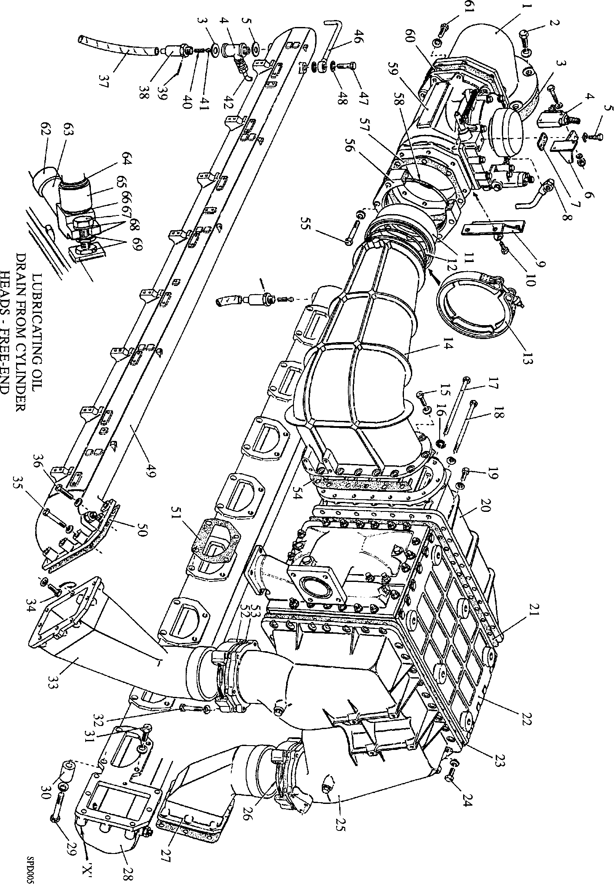

-U 4^ 4*.

Fig LC.l Air inlet manifolds and piping

Key To Numbers

1. Turbocharger
2. Lifting bracket
3. 'O' ring
4. Nut
5. Coolant pipe turbocharger to inlet casing
6. Coolant outlet elbow
7. Joint inlet casing to turbocharger
8. Dowel
9. Inlet casing
10. 'O' ring
11. 'O'rings
12. Philidas nut
13. Centre philidas nut
14. Exhaust bend
15. 'O' ring
16. Setbolt
17. Sleeve
18. 'O' rings
19. Connecting pipe
20. Setscrew
21. Charge air heater/cooler support bracket
22. O' ring
23. Setbolt, charge air heater/cooler to bracket
24. Setbolt, exhaust bend to manifold
25. Dowty seal
26. Adaptor
27. Coolant coupling
28. Setscrew
29. ’O’ ring
30. Coolant ’Y* piece
31. Setbolt
32. Coolant bend
33. ’O’ ring
34. Setbolt, coolant bend to manifold
35. Setbolt, turbine casing to manifold
36. ’O’ ring
37. Philidas nut
38. Setscrew
39. Air shutdown valve support bracket
40. Setscrew
41. Setbolt
42. Locking plate
43. Support bracket
44. Distance piece, short
45. Distance piece, long
46. Angle bracket
47. Setbolt
48. Philidas nut
49. Philidas nut
50. Turbocharger foot
51. Capscrew
52. ’O' ring
53. 'O’ ring
54. Adaptor
55. 'O’ ring
56. Setscrew
57. Drain bend
58. 'O' ring
59. Drain elbow
60. Coupling
61. Coupling
62. Clamp band

63 Drain pipe

1. Philidas nut
2. Joint

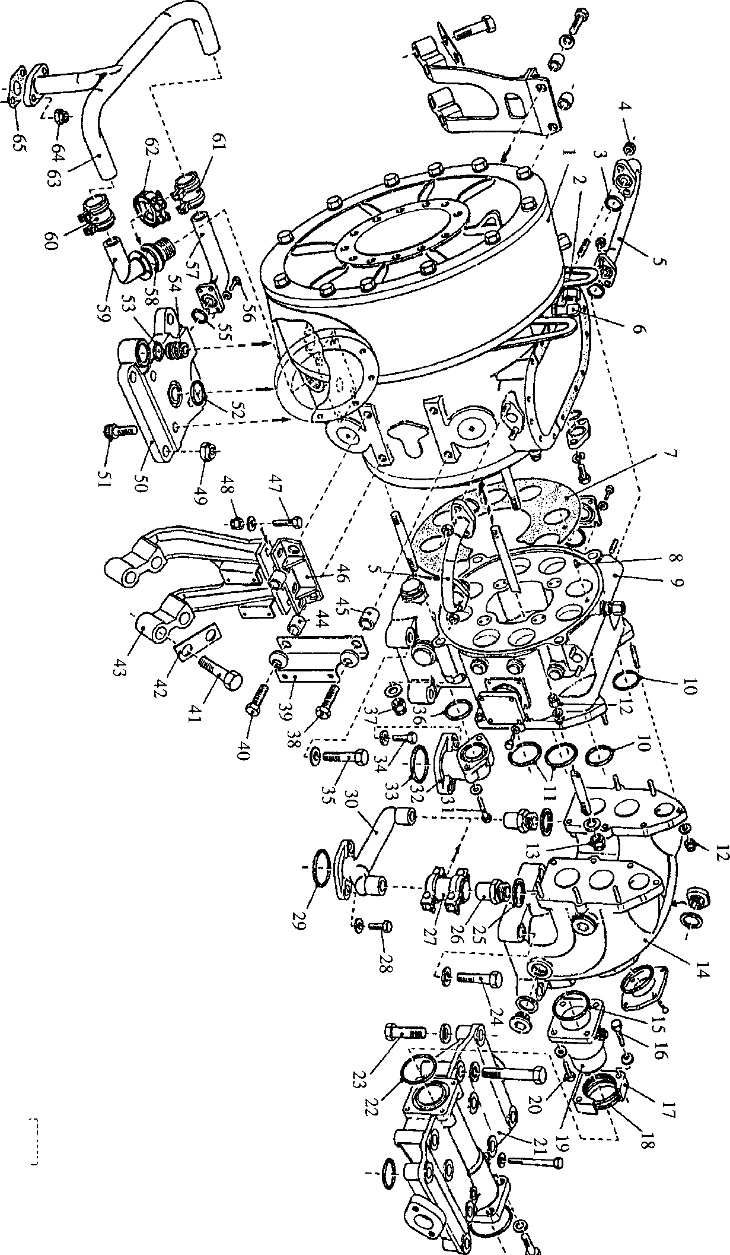

**SPD00509**

Fig LC.2 Turbocharger inlet casings and brackets

|  |  |
| --- | --- |
| Key To Numbers | |
| 1. | Setbolt |
| 2. | Setbolt |
| 3. | Charge air cooler support bracket |
| 4. | Drain pipe |
| 5. | Coolant direction pipe |
| 6. | 'O' ring |
| 7. | Setbolt |
| 8. | Setbolt |
| 9. | Coolant bend |
| 10. | 'O' ring |
| 11. | Setscrew |
| 12. | Stud |
| 13. | Plug |
| 14. | Philidas nut |
| 15. | 'O' ring |
| 16. | 'O' ring |
| 17. | Free end manifold |
| 18. | Stud coupling, long |
| 19. | Hose clips |
| 20. | Hose |
| 21. | Stud coupling, short |
| 22. | Clamp segments |
| 23. | Band clamp |
| 24. | Setscrew |
| 25. | Exhaust bellows |
| 26. | Setscrew |
| 27. | Setbolt |
| 28. | 'O' ring |
| 29. | Countersunk socket head screw |
| 30. | Blanking plate |
| 31. | Drive end manifold |
| 32. | Aluminium washer |
| 33. | Plug |
| 34. | 'O' ring |
| 35. | Philidas nut |
| 36. | Exhaust gasket |
| 37. | 'O' ring |

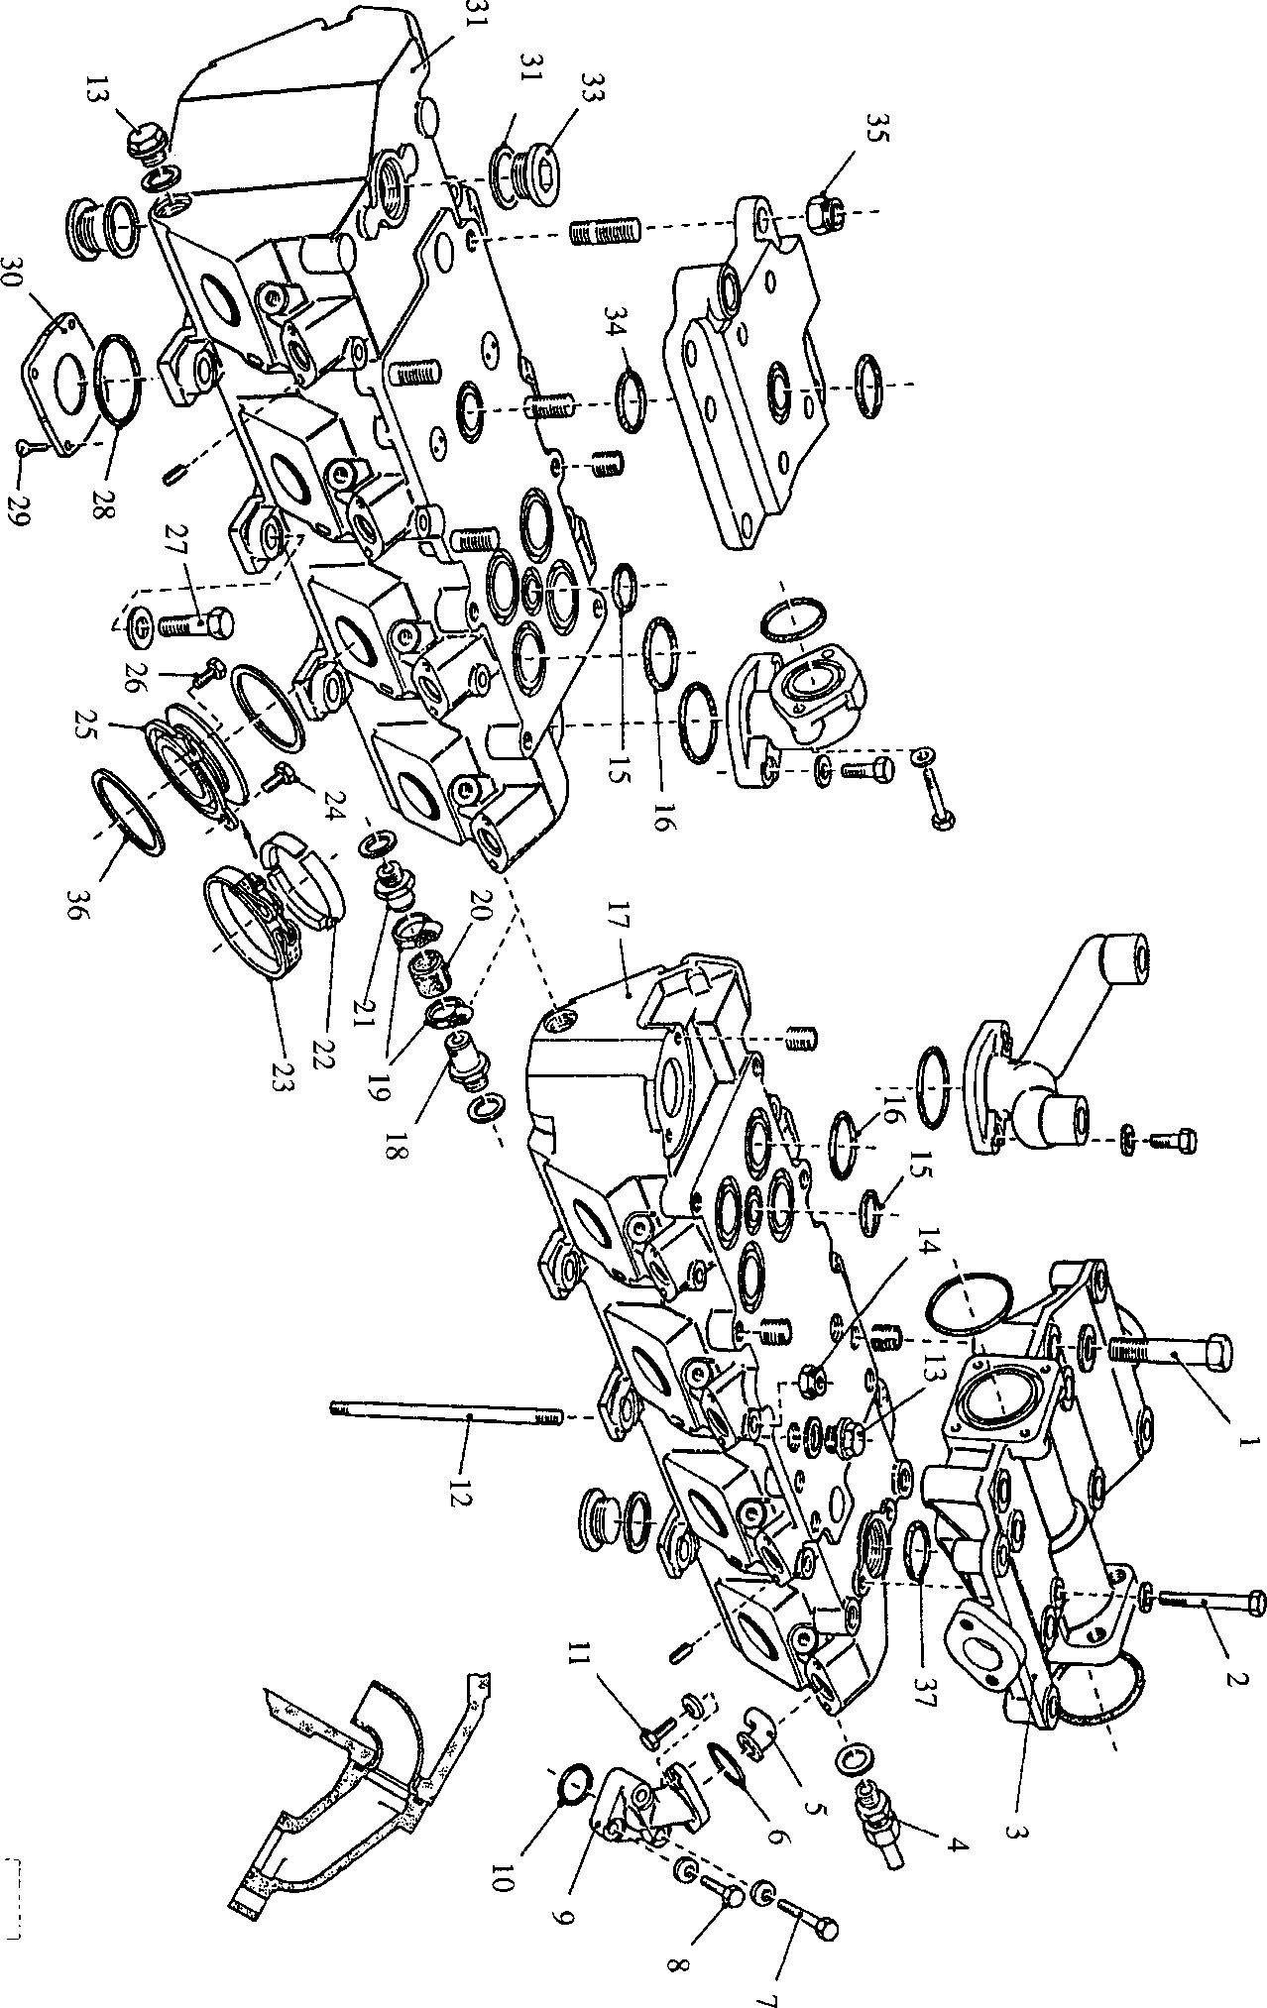

**SPD00510**

Fig LC.3 Exhaust Manifolds